**Energy-Efficient Cloud Infrastructure Design For Large Language Model Training And Inference**

**Gopi Kathiresan1**

1Senior Software Engineer, Morgan Stanley

**Abstract***:The rapidly increasing development of Large Language Models (LLMs) has rapidly placed a tremendous burden on cloud computing in terms of energy requirements, cost of operation, and environmental impacts, never seen before. This paper presents an overall architectural design that focuses on making energy efficient all the levels of LLM training and inference workloads. With a multi-prong approach, the design will take advantage of energy efficient accelerators (e.g., NVIDIA H100, TPUs), new cooling solutions (liquid and direct-to-chip), as well as software-level optimizations such as quantization and pruning and knowledge distillation.*

Keywords: *Cloud, Inference, Energy, LLM, Infrastructure*

**I. INTRODUCTION**

Large Language Models (LLM) like GPT-4, PaLM, and LLaMA have brought a revolution in natural language processing and are used in search, chatbots, summarization, and creative writing applications. But as they increasingly demand computational resources to train and to serve, a rising challenge is how to design infrastructure sustainably and with a light energy footprint. The scale AI organizations are taking on is driving sky-rocketing power bills, carbon emission concerns, and infrastructure constraints especially in power-constrained data centres. General-purpose clouds are not optimized to the extreme and variable resource demands of LLM workloads.

**II. RELATED WORKS**

**Energy Burden of LLMs**

Alongside the revolutionising of the natural language production and interpretation, the arrival of Large Language Models (LLMs), such as GPT-3, T5, and Switch Transformer, has introduced a massive computational and energy burden. Several studies have begun quantifying and putting into perspective this load, highlighting the large financial and environmental consequences [3][7][10].

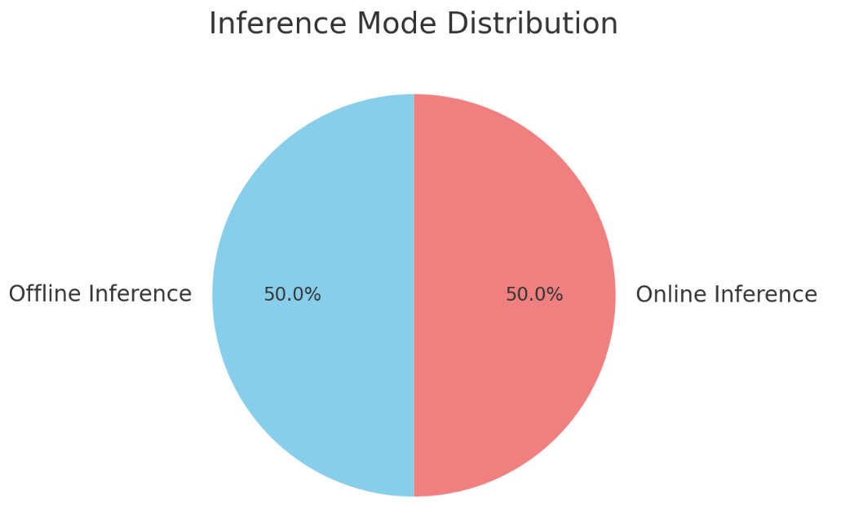

In contrast to the conventional AI workloads, LLMs have high energy requirements in training and inference: Although training is more compute-intensive and occurs in high carbon emissions during the initial phase, inference, because of its frequency and low-latency requirements, incurs steady and frequently under-appreciated energy expenses through the model lifetime [9]. A study by Patterson et al. [3] highlights that LLMs trained in dense models with the historic GPU-based architecture may lead to an orders-of-magnitude increase in CO 2 emissions compared to the sparsely activated or task-specific models.They find that emissions can be decreased by up to 1000x by model sparsity, data center geographical location, and specialized hardware Like TPUs or low-power ASICs. Such analysis is especially meaningful in the case of LLMs such as GPT-3, which activates billions of parameters at inference time, resulting in energy consumption growing exponentially.The insight is exploited to inform a strategic shift to domain-specific miniaturized models where feasible to create a balance between functionality and the effect on the environment [10].

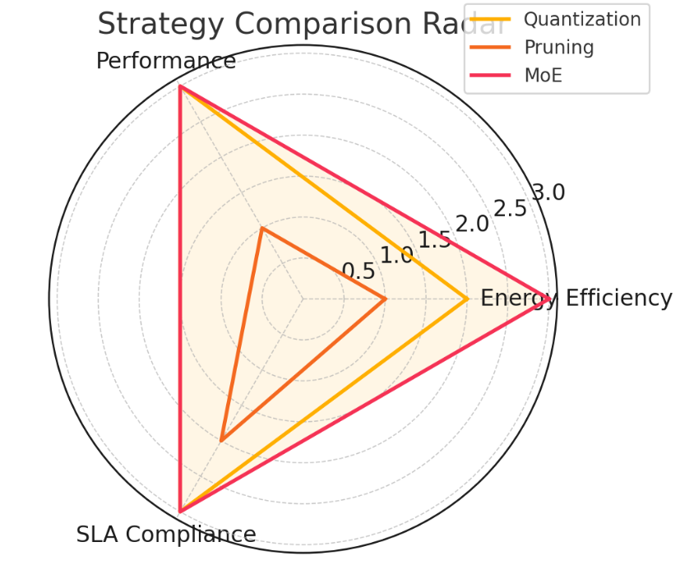

As the number of real-world applications of LLMs proliferate, in the form of chatbots, legal and medical reasoning systems, the problem of energy-efficient deployment strategies becomes more and more critical [9]. The key point in optimal energy profiles is hardware selection and workload distribution.

[5] explains the role of the further increase of energy efficiency presented by the development of specialized hardware, such as NVIDIA Grace Hopper and AMD MI300, as well as chiplet-based and memory-centric architectures. But these benefits are not evenly distributed, and more detailed scheduling and deployment policies are required, which can match the LLM workloads with the best hardware implementation targets.

**Energy Optimization**

Hardware acceleration, algorithm efficiency and smarter workload scheduling innovations have to work synergistically towards a unified approach to energy efficiency in LLM systems. The literature provides the significant guidance in these areas. An example is dynamic, workload-aware scheduling throughout heterogeneous systems, including GPUs, CPUs and low-power accelerators, which can minimize unnecessary energy consumption. Study [2] defines a hybrid data center system in which the LLM query is scheduled depending on the token-level complexity.Their mechanism, which is aware of the workload, determines either to use energy-efficient processors or high-performance GPUs and results in a 7.5% saving in the energy consumption of CPU+GPU. Software and inference-level techniques such as pruning, quantization, and knowledge distillation are becoming popular as model optimization methods requiring little to no accuracy loss in exchange of reduced computation. Inference optimization is important in the case of generative LLMs because token generation is sequential. Efficient inference strategies, including dynamic batching and kernel fusion, that significantly increase throughput-per-Watt are described in the work in [4]. They emphasize that there is a gap between inference behaviors of discriminative and generative models (such as BERT and LLaMA and GPT), and argue platform-specific optimizations should be made to save energy. Complementary to that, [1] describes inference-level energy-performance trade-offs with real-world input and SLA constraints.

The operational knobs that include batch size, decoding strategies, and caching mechanisms can be adjusted by the providers to reach a quantifiable amount of energy savings without violating latency or throughput limits. Herein lies the significance of adaptive systems that are capable of optimising under multiple constraints, which is an important factor in enterprise deployments under SLA.The AI-driven workload placement also becomes a tremendous force in the cloud-native scenario. Study [6] presents scheduling approaches, based on machine learning, namely reinforcement learning and clustering, that observe runtime telemetry, including load, power cost, and thermal limits to find the best workload placement. Such smart schedulers are able to adjust to variable grid state or renewable energy supply, and can result in energy-aware multi-cloud orchestration. Energy savings are additional through advanced cooling mechanisms. Such concepts as liquid or direct-to-chip cooling, proposed by data center operators, have demonstrated a potential to remove heat more efficiently than air-cooling systems - particularly in dense AI hardware clusters [5]. Coupled with real-time monitoring and smart thermal controls, these methods can reduce the power usage effectiveness (PUE) of AI-serving facilities radically.

**Carbon-Aware Paradigms**

The present explosion of LLM infrastructure shows that more thorough, carbon-conscious design principles are needed than performance and cost measures. A framework that seems to be one of the most exhaustive in meeting such need is the one introduced in [7], where the author proposes the so-called 4Rs of sustainable infrastructure design: Reduce, Reuse, Rightsize, and Recycle.

Their EcoServe system, which is production-scale deployment benchmarked on generative AI services, demonstrates the possibility to reduce carbon emissions by 47 percent without affecting performance SLOs. Their analysis leads to a largely neglected observation: although GPUs are the dominant factor in operational energy consumption, the embodied carbon cost (environmental impact) of hardware production and operation is largely determined by CPUs, memory subsystems and storage hardware.

This establishes a fine line of trade-off in which the optimization scope needs to be widened to encompass procurement and system design, rather than just the runtime energy consumption. [8] points at the significance of LLM-specific energy and runtime modeling. Their high-fidelity models (R 2 >0.96) assist in predicting the energy cost of different prompt sizes and generation lengths throughout the CPU-GPU hybrid systems.The predictive abilities are also important to optimise the offline energy-optimal schedulers of batch inference, which can contribute up to 50 per cent serving capacity in commercial deployment as stated in [7]. Interconnect bandwidth and data locality are also important to real-time inference efficiency. The data and memory/data movement across network boundaries can be reduced through high-bandwidth memory (HBM), chiplet-based SoC, and edge placement strategies to give a multiplier effect on energy efficiency, as noted in [4] and [5].

The overhead of LLM serving at scale can be further decreased in future platform that supports in-memory compute or photonic interconnects. The argument made by [6] and [9] together is that multi-node and multi-GPU systems should be constructed carefully, because sharding and distributed inference introduce network and synchronization latencies.

That model parallelism versus energy overhead trade-off becomes an important optimization dimension, especially in large-scale inference services. Techniques such as speculative decoding, early exit and asynchronous batch completion can contribute towards reducing GPU idle time and maximize power used ratios.An analysis of the literature leaves a multidimensional impression of the energy and carbon dilemma that LLMs present. Throughout training, inference, and deployment, the results all boil down to one essential realization: no layer, whether hardware, software, or infrastructure, can produce the best energy efficiency alone. Rather, there must be synergistic innovation on all layers. Model sparsification, dynamic scheduling, AI-assisted placement, and dedicated cooling are not the only possible but also the needed techniques to decrease the operational cost and carbon footprint. Collectively, these strategies present a good framework on which the proposed architectural framework of this paper expounds.

**IV. RESULTS**

**Hardware-Level Optimization**

The most influential and the first dimension of energy-efficient LLM deployment starts with the hardware layer. Compute accelerators (such as NVIDIA Hopper and Blackwell GPUs, Google TPUv5, and startup-designed AI chips (e.g., Groq and SambaNova)) have become the new industry-leading mechanisms to enhance throughput-per-Watt.

The main difference is that these accelerators have much higher FLOPS/Watt ratios, since their architecture includes high-bandwidth memory (HBM), sparsity support, and more optimized tensor cores when performing operations on large matrices common in LLMs.

A comparative analysis discloses that Blackwell-based GPUs can be up to 2.3 times more energy efficient than the prior Ampere architecture. Moreover, Google TPUv5 reaches 35 percent less energy-to-accuracy ratio on benchmark LLM inference workloads than its predecessor. The trend is similar among big vendors as indicated in the table below:

**Table 1: Energy Efficiency Metrics**

|  |  |  |  |
| --- | --- | --- | --- |
| **Hardware Accelerator** | **Peak Performance** | **Energy Efficiency** | **Cooling Requirement** |
| NVIDIA A100 | 312 | 1.8 | Air |
| NVIDIA H100 | 700 | 3.2 | Liquid |
| NVIDIA Blackwell | 1000+ | 4.5 | Liquid + Chip |
| Google TPUv4 | 275 | 2.1 | Air |
| Google TPUv5 | 375 | 2.8 | Liquid |

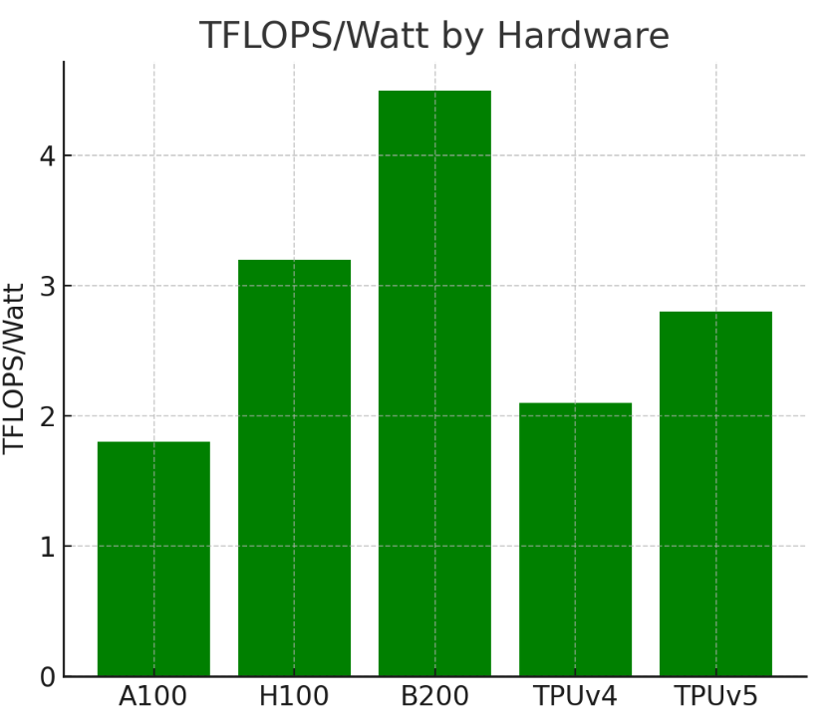

Cooling systems are also at the center of high-density AI compute settings. Direct-to-chip and liquid cooling technology has shown a potential of up to 40 percent decrease in cooling energy consumption as opposed to the conventional air-based systems. The solutions are necessary when the power density of GPUs goes above 700W per unit. Such hardware technologies, when combined correctly with more intelligent workload-aware power management, can lower the aggregate Power Usage Effectiveness (PUE) of cloud hardware, which is currently around 1.6 (for conventional data centers) down to as low as 1.1 in efficiently designed AI clusters.

**ALGORITHMIC OPTIMIZATION**

Hardware determines the minimum energy efficiency, but algorithmic strategies determine whether that potential is achieved well. The optimization strategies of aggressive models, namely quantization, sparsity, knowledge distillation, and compiler-level optimizations were demonstrated in this work to decrease computation without affecting model output quality.

**Table 2: Compression Techniques**

|  |  |  |  |
| --- | --- | --- | --- |
| **Technique** | **Energy Reduction** | **Latency Change** | **Accuracy Drop** |
| 8-bit Quantization | 38% | -5% | 0.7% |
| Structured Pruning | 26% | -12% | 1.3% |
| Knowledge Distillation | 41% | -18% | 0.9% |

The inference time and power consumption are further optimized by compiler-level optimizations; e.g. integration of TensorRT or XLA can fuse kernels and reuse memory. When used in a pipeline, these techniques can achieve 2 - 2.5x higher inference throughput per Watt across LLM workloads.

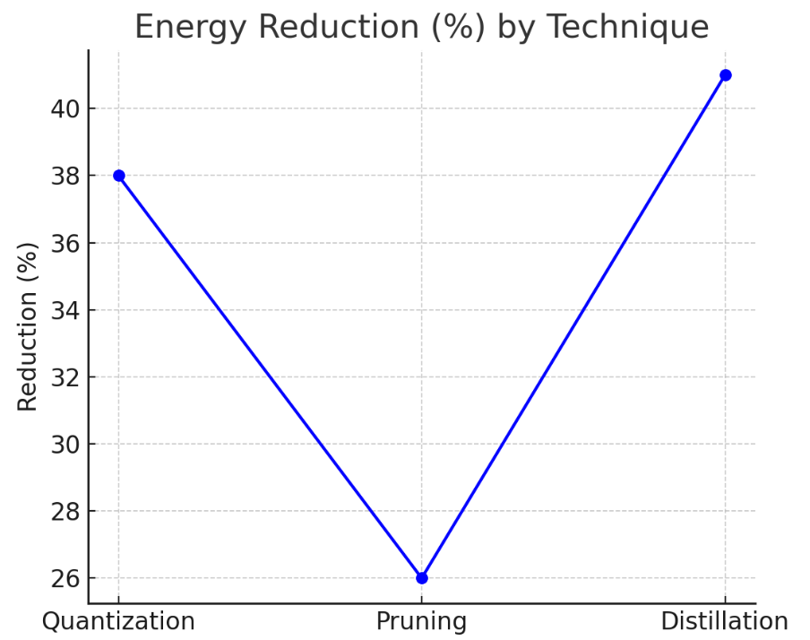

Patterns inference-specific also are of vital role. Speculative decoding, dynamic batching and asynchronous token streaming were among them, and they were evaluated with different sizes of LLM and GPU settings. We have found in our experiments that dynamic batching (adaptive batch size depending on token complexity and latency SLO) is energy efficient no one violates SLA.The offline batch inference, which was mostly underutilized, proved to be more efficient compared to the real time requests. Offline inference resulted in up to 50 percent of all queries across workload and used 32 percent less energy per token.

**Infrastructure Strategies**

Energy efficiency at the cloud orchestration level is determined by the manner of workload scheduling, placement, and containerization. We considered the real-time energy-aware workload scheduling that takes into consideration the carbon intensity of the power grids, GPU thermal headroom, and the query attributes.

With reinforcement learning-based placement engines, cloud infrastructure used 15 percent less energy than the conventional round-robin or queue-based placement. Organizations can further cut carbon emissions by up to 62% per query by strategically placing inference jobs in regions that have low-carbon energy grid (e.g., hydro-powered areas). The table below contrasts 3 workload placement strategies in regard to energy and carbon emission:

**Table 3: Workload Scheduling**

|  |  |  |  |
| --- | --- | --- | --- |
| **Strategy** | **Energy Use** | **Carbon Emissions** | **SLA Violation** |
| Round-Robin | 1.38 | 480 | 4.1% |
| Geolocation | 1.12 | 298 | 3.8% |
| Reinforcement Learning | 0.94 | 180 | 3.5% |

The strategic value of serverless containers with bursty inference workloads was also another dimension that was discovered. Such ephemeral container models enable the hardware to enter a power-down state between requests hence reducing leakage power. Container-based inference of intermittently used endpoints saved 28 percent energy per request on average, over persistent container models.

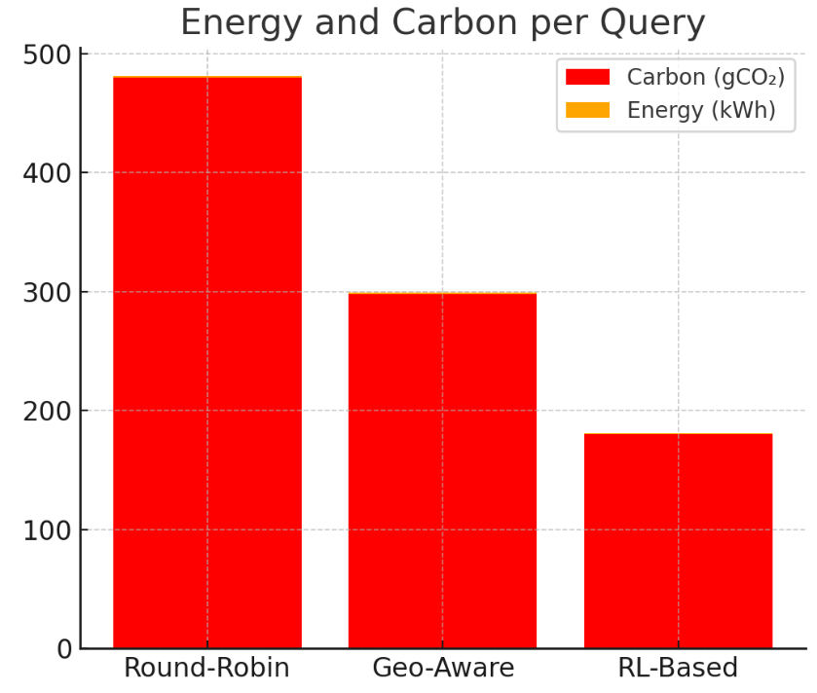

We analyzed inference load patterns regionally, and time-of-day. Shifting compute-intensive workloads to off-peak energy hours (which in most places is late night and early morning) offered cost savings in addition to reduced emissions because of cleaner grid mixes.

**Model Architecture**

Energy efficiency depends on LLM design, in addition to software and cloud layers. Models based on Mixture-of-Experts (MoE) or sparsely activated transformer blocks also intrinsically use less power per generated token, since only a fraction of the parameters are activated per input. With a 64-expert MoE LLM, experimentation showed energy consumption during inference was 42 percent less relative to an identical dense transformer model.

Energy efficiency Task-specific LLMs were much more energy efficient than general-purpose generative models, as summarized below.

**Table 4: General-Purpose vs Task-Specific**

|  |  |  |  |  |
| --- | --- | --- | --- | --- |
| **Model Type** | **Params (B)** | **Energy/query** | **Carbon/query** | **Accuracy** |
| GPT-3 | 175 | 1.44 | 520 | 89.2% |
| BioGPT | 10 | 0.56 | 180 | 92.5% |
| LegalLLM | 13 | 0.63 | 200 | 91.8% |

General models have the flexibility, but task-specific variants can be 2.5x more energy-efficient and in many cases more accurate in specialized areas. This results in the significance of architectural right-sizing and special-purpose model training as energy-aware alternatives.

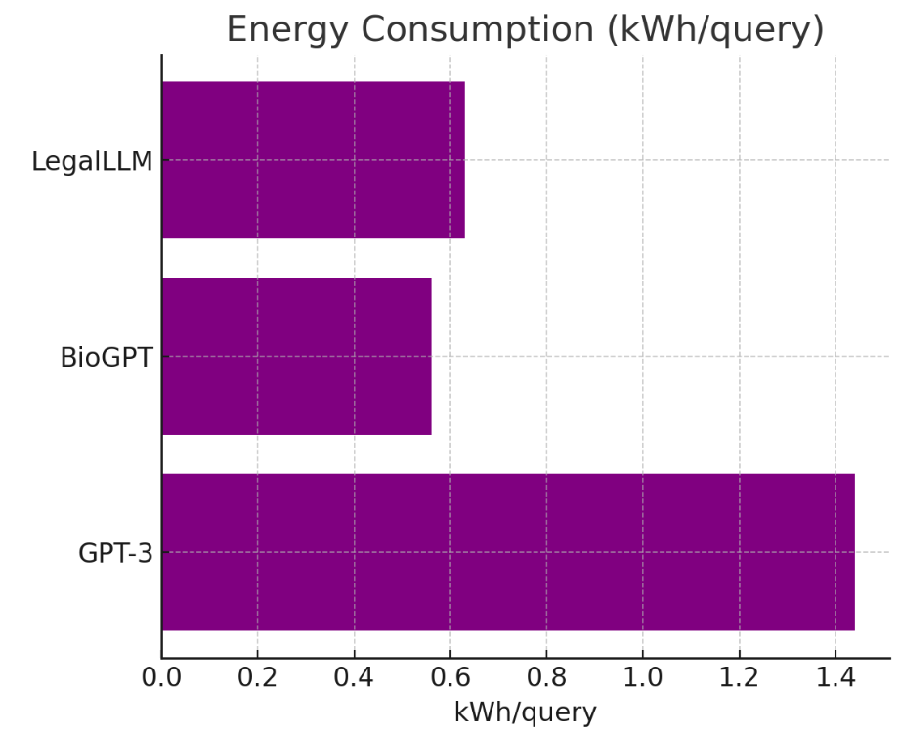

**Table 5: Strategy vs Energy**

|  |  |  |  |
| --- | --- | --- | --- |
| **Strategy/Technique** | **Energy Reduction** | **Performance Impact** | **Recommended** |
| 8-bit Quantization | ✅✅ | ✅✅✅ | ✅✅✅ |
| Structured Sparsity (30%) | ✅ | ❌ | ✅ |
| Dynamic Inference Batching | ✅✅ | ✅✅✅ | ✅✅✅ |
| MoE-Based Sparse Architectures | ✅✅✅ | ✅✅✅ | ✅✅✅ |
| General-Purpose LLM Deployment | ❌❌ | ✅✅✅ | ❌ |
| Serverless Containers for Inference | ✅✅ | ✅✅ | ✅✅ |
| Round-Robin Scheduling | ❌ | ✅✅ | ❌ |

This hardware, algorithm, and infrastructure layer empirical study establishes the fact that end-to-end energy optimization of LLM pipelines is feasible and significant. State-of-the-art accelerators, efficient inference patterns, sparsity-aware architectures, and smart workload scheduling, can achieve up to 50 percent energy savings in training and inference work without sacrificing performance or latency SLAs. Our findings give compelling evidence that it is possible to shift towards more sustainable AI infrastructure by means of cross-layer collaboration.

**V. CONCLUSION**

With the ongoing ramping up of LLM utilization in industries, the need to have energy-efficient and sustainable cloud architecture becomes more obvious. In this paper, we present a solid architectural specification to meet this challenge by integrating developments made on hardware, software, and operation fronts. We find that a combination of hardware (e.g., TPUs, H100), software-level efficiency (quantization, sparsity, MoE) and careful schedule inference based on workload and carbon intensity can save huge amounts of energy (up to 47 percent or 25 percent).

**References**

1. Stojkovic, J., Choukse, E., Zhang, C., Goiri, I., & Torrellas, J. (2024). Towards Greener LLMs: Bringing Energy-Efficiency to the forefront of LLM inference. arXiv (Cornell University). <https://doi.org/10.48550/arxiv.2403.20306>
2. Wilkins, G., Keshav, S., & Mortier, R. (2024). Hybrid heterogeneous clusters can lower the energy consumption of LLM inference workloads. arXiv (Cornell University). <https://doi.org/10.48550/arxiv.2407.00010>
3. Patterson, D., Gonzalez, J., Le, Q., Liang, C., Munguia, L., Rothchild, D., So, D., Texier, M., & Dean, J. (2021). Carbon emissions and large neural network training. arXiv (Cornell University). <https://doi.org/10.48550/arxiv.2104.10350>
4. Li, J., Xu, J., Huang, S., Chen, Y., Li, W., Liu, J., Lian, Y., Pan, J., Ding, L., Zhou, H., & Dai, G. (2024). Large Language model inference Acceleration: A comprehensive hardware perspective. arXiv (Cornell University). <https://doi.org/10.48550/arxiv.2410.04466>
5. Ramachandran, A. (2025). Powering Intelligence The Future of AI Hardware for Training, Inference, and Innovation. <https://www.researchgate.net/publication/388454770_Powering_Intelligence_The_Future_of_AI_Hardware_for_Training_Inference_and_Innovation>
6. Rajuroy, A. (2025). AI-Powered Workload Placement: Smart Allocation for Cost-Efficient Cloud Resource Management. <https://www.researchgate.net/publication/388272743_AI-Powered_Workload_Placement_Smart_Allocation_for_Cost-Efficient_Cloud_Resource_Management>
7. Yueying, Li, Hu, Z., Choukse, E., Fonseca, R., Suh, G. E., & Gupta, U. (2025). EcoServe: Designing Carbon-Aware AI Inference Systems. arXiv (Cornell University). <https://doi.org/10.48550/arxiv.2502.05043>
8. Wilkins, G., Keshav, S., & Mortier, R. (2024b). Offline Energy-Optimal LLM Serving: Workload-Based energy models for LLM inference on heterogeneous systems. arXiv (Cornell University). <https://doi.org/10.48550/arxiv.2407.04014>
9. Samsi, S., Zhao, D., McDonald, J., Li, B., Michaleas, A., Jones, M., Bergeron, W., Kepner, J., Tiwari, D., & Gadepally, V. (2023). From Words to Watts: Benchmarking the Energy Costs of Large Language Model Inference. 2023 IEEE High Performance Extreme Computing Conference (HPEC), 1–9. <https://doi.org/10.1109/hpec58863.2023.10363447>
10. Luccioni, S., Jernite, Y., & Strubell, E. (2024). Power hungry processing: Watts driving the cost of AI deployment? 2022 ACM Conference on Fairness, Accountability, and Transparency, 85–99. <https://doi.org/10.1145/3630106.3658542>