**Importance Of Continuous Innovation In Social Technology And Digital Marketing**

**Chong Huo Bin1, Wong Chee Hoo2, Prakash Shaurya3, Kheyali Roy4**

1INTI International University, i25033436@student.newinti.edu.my

2Faculty of Business and Communications, INTI International University, Negeri Sembilan, Malaysia, Department of Economic Sciences, Wekerle Sandor Uzleti Foiskola, Budapest, Hungary, Faculty of Management, Shinawatra University, Pathum Thani, Thailand, International Institute of Management and Business,

Minsk, Belarus, Cheehoo.wong@newinti.edu.my

3Faculty of Business, Indhira Gandhi University, India, 06626021737@visva-bharati.ac.in

4Department of Social Work (Senior), Assam Don Bosco University, India, [kheyali.roy@dbuniversity.ac.in](mailto:kheyali.roy@dbuniversity.ac.in)

***Abstract:*** *Meta, one of the world’s leading social technology companies, serves billions of users globally and generates substantial revenue through targeted digital advertising. The company holds a dominant position in the global digital advertising industry. However, despite its market leadership, Meta faced increasing competition and a significant year-over-year decline in net income in 2022. This downturn highlights the critical need for continuous innovation and infrastructural investment, even for a tech giant like Meta. In response to evolving industry dynamics and the growing significance of Artificial Intelligence (AI), the company shifted its focus toward AI-driven infrastructure and services—part of a broader global trend in technology investment. As a result of this strategic pivot, Meta experienced a strong financial rebound, with substantial growth in net income in 2023 and 2024. This turnaround underscores the impact of timely innovation and investment in emerging technologies, helping Meta to enhance its competitive edge and improve overall financial performance in a rapidly changing digital landscape.*

***Keywords****: Continuous Innovation, Social Technology, Digital Marketing, Sustainable Growth*

# **1.1 Company Profile**

## **1.1.1 Background of the company**

Meta Platforms, Inc. is a leading multinational technology company which is previously known as Facebook, Inc. headquartered in Menlo Park, California, United States. The company was founded in 2004 by Mark Zuckerberg alongside his college peers Eduardo Saverin, Andrew McCollum, Dustin Moskovitz, and Chris Hughes while they were students at Harvard University. Initially launched as a social networking site exclusive to college students, Facebook quickly gained popularity and expanded to a global user base within a few years (Meta, 2021).

In October 2021, Facebook, Inc. was officially rebranded as Meta Platforms, Inc. This strategic rebranding was initiated to reflect the company’s evolving mission and broader vision to build the metaverse, which Meta defines as a set of interconnected digital spaces that enable immersive, real-time interaction through technologies such as virtual reality (VR) and augmented reality (AR) (Meta, 2021). Despite this transition, Meta continues to maintain and grow its foundational social networking services while simultaneously investing in advanced technologies to support future digital experiences.

## **1.1.2 Products and Services**

Meta Platforms, Inc. operates under two primary business divisions, which are Family of Apps (FoA) and Reality Labs (RL). The Family of Apps division includes several widely used digital communication platforms. These include Facebook, which supports social interaction and community building through features such as feeds, reels, stories, groups, and marketplace. Another key platform is Instagram, which enables visual and social engagement through image and video sharing, stories, live streaming, and messaging tools. Additionally, Messenger is an application designed for multi-format communication across devices that offers text, voice, and video functionalities. The FoA segment also incorporates Threads, a platform developed for sharing real-time, text-based updates and public discussions. Furthermore, it includes WhatsApp, a messaging service that facilitates secure, private communication and transactions between individuals and businesses (Yahoo Finance, 2024).

These platforms together serve billions of users globally and are primarily monetized through targeted digital advertising, which remains Meta’s principal revenue source (Statista, 2023).

The Reality Labs division focuses on research and development in immersive technologies. This includes the Meta Quest series of VR headsets, Horizon Worlds (a social VR platform), and Meta Avatars, which allow users to represent themselves in digital environments. Meta Quest 3, released in 2023, incorporates mixed reality features and advanced spatial computing capabilities, enabling applications across gaming, education, remote work, and training (Meta, 2023a).

## **1.1.3 Position of the Industry**

Meta is widely recognized as one of the "Big Five" technology firms, alongside Google (Alphabet), Apple, Amazon, and Microsoft. It holds a dominant position in the global digital advertising industry, accounting for approximately 20% of worldwide digital ad spending in 2023 (eMarketer, 2023). Moreover, with over 3 billion monthly active users across its platforms, Meta operates the world’s largest online social ecosystem (Statista, 2023).

In addition to its stronghold in digital advertising and social media, Meta is emerging as a key player in the extended reality (XR) sector, which includes VR, AR, and mixed reality. Through its investments in Reality Labs and the metaverse, the company is attempting to diversify its revenue streams and position itself as a pioneer of next-generation digital experiences. While the commercial viability of the metaverse remains uncertain, Meta’s substantial financial and technological commitment places it in a leading role in shaping the future of immersive digital interaction (The Verge, 2023).

## **1.1.4 Basic Corporate Information and Strategy**

## Meta Platforms, Inc. is a publicly traded company listed on the NASDAQ stock exchange under the ticker symbol META. As of 2024, the company employs over 70,000 individuals globally and operates in more than 90 countries (Meta, 2023b). The company’s mission is "to give people the power to build community and bring the world closer together," while its long-term vision is to enable a fully realized metaverse that enhances how people connect, learn, and collaborate (Meta, 2021). Abueid et al. (2025) explains creative, disruptive financial ecosystems and demonstrates how the FinTech ecosystem is upending the financial services sector.

Over the last five years, Meta Platforms Inc. has experienced significant financial fluctuations. From 2019 to 2021, the company saw steady revenue growth, driven by strong digital advertising performance. However, in 2022, profits declined due to increased competition, economic challenges, and substantial investments in the metaverse. By 2023, Meta began recovering, aided by cost reductions and growth in artificial intelligence initiatives, reflecting its adaptability and strategic focus (Yahoo Finance, 2024).

Meta’s strategy is focused on three core pillars which are maintaining and expanding its existing suite of social applications by investing in AI and machine learning for personalized experiences and content moderation and leading innovation in AR/VR technologies. The company has also emphasized user privacy, ethical AI use, and responsible platform governance, especially in response to increased regulatory scrutiny and public concerns regarding misinformation, data use, and online safety (Meta, 2023c).

In conclusion, Meta Platforms, Inc. has evolved from a single social networking site into a global technology leader with diversified interests in social media, virtual reality, and digital ecosystems. While challenges remain, particularly in the areas of regulation and long-term monetization of immersive platforms, Meta continues to play a significant role in shaping the future of digital communication and interaction.

# **2.1 Horizontal and Vertical Analysis**

## **2.1.1 Total Revenue Analysis**

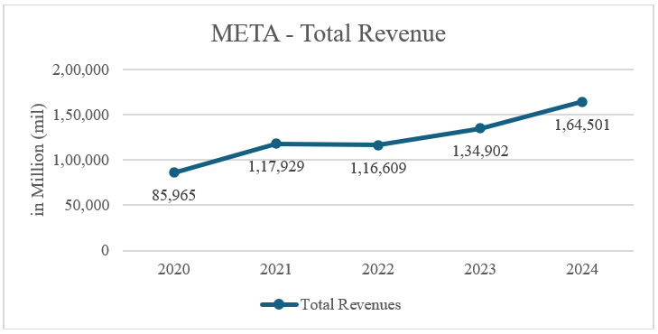

**Figure 1:** Total Revenue Chart

Based on the line graph, META has shown strong revenue growth from the year 2020 to the year 2024. However, META suffered a total revenue growth declined in year 2022, one crucial factor is global economy uncertainty where the rising inflation has weakened the spending power, but the impact is seen throughout entire industry, so it does not indicate a weakness from META itself. META continues to show revenue growth later in the year 2023 and 2024, generating 134 billion USD and 164 billion USD in respective years. Majority revenue of META come from social network advertising, that has shown more and more businesses today are spending more digital advertising with META globally and relies on META’s advertising platform to generate leads and income to build and grow their businesses (Dixon, Stacy Jo (2025). This is a strong indicator and response from the market where META’s platform is essential and becoming a trend to their business and willing to spend more as META can address their business needs.

## **2.1.2 Total Gross Profit Analysis**

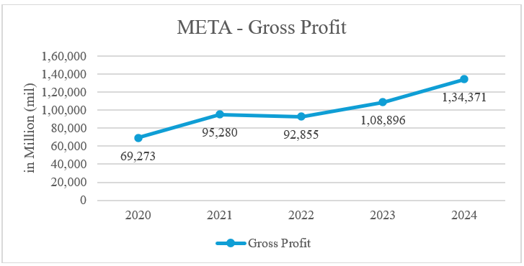

**Figure 2:** Gross Profit Chart

In our horizontal analysis on META’s Gross Profit from 2020 to 2024, META shows a strong Gross Profit growth over the last 5 years. From 69 billion USD in the year 2020 to 134 billion USD in 2024, the total Gross Profit earned almost double in last 5 years and this indicates the company’s direction is on the right track, gaining more market share and the company is on up-trend. It also shows that global digital advertising marketing spending has been increasing rapidly with META. With the latest implementation of AI into digital marketing by Mark Zuckberg, it will further enhance the efficiency and effectiveness of advertising to better target a specific audience. These implementations and improvements alone may attract additional advertisers and further boost META’s advertising revenue and gross profit in the foreseeable future.

## **2.1.3 Net Income Analysis**

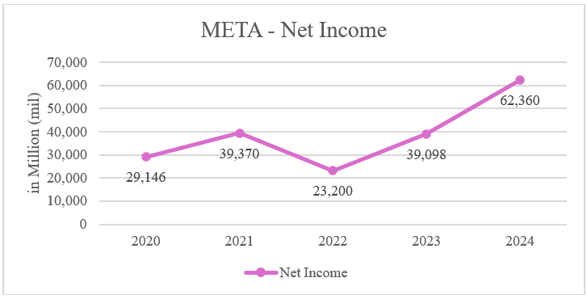

**Figure 3:** Net Income Chart

Based on the 5 years Net Income line graph above, META’s net income has grown from 29 billion USD to 39 billion USD from year 2020 to year 2021. However, in year 2022 the total net income declined to 23 billion USD which decreased 41% from year-to-year net income. Mark Zuckerberg said the decision to aggressively increase META’s investment had been a mistake and the global economy downturn because of COVID-19 pandemic had a big impact. Also, increased competition from competitors such as TikTok, META’s closest competitor to its business nature has also attributed to the net income decline in 2022 (Levy, 2022). Mark Zuckerberg then made some drastic changes in keeping META efficient, laid off a total of 21,000 of its workforces in 2023, launched Threads and shifted focus on artificial intelligence (AI). As a result, not only the net income went back up to 39 billion USD in 2023, but also grew tremendously to 62 billion USD in 2024. These changes are significant and right on the AI trend from the results. META has good potential to keep the momentum despite the competitive environment (Gazi et al., 2024) (Levy, 2022).

**2.1.4 Balance Sheet Analysis**

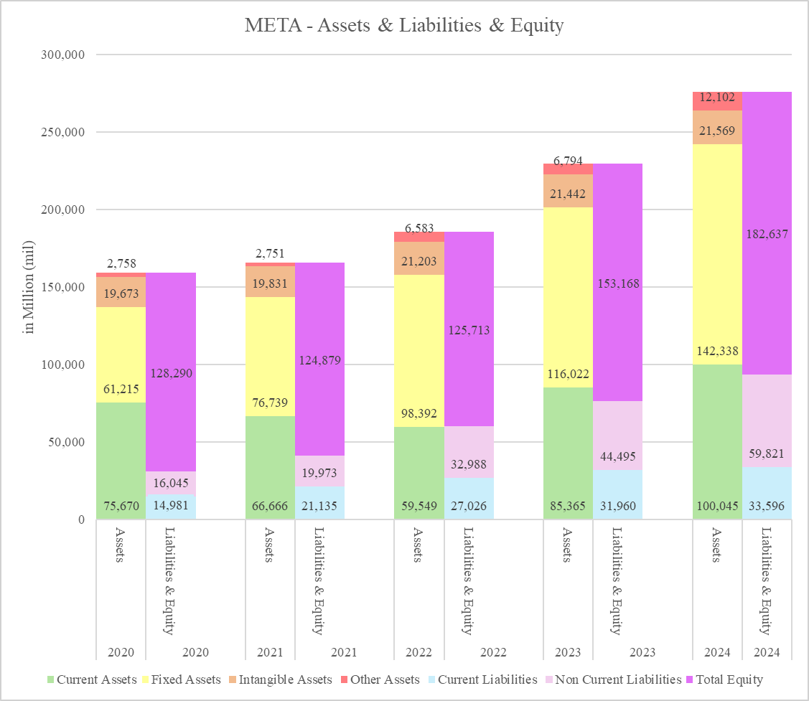

**Figure 4:** Balance Sheet Chart

Referring to bar chart 2.1 above, it shows a complete picture of META’s past 5 years’ financial position. META has very strong and solid assets and as opposed to its total liabilities combined. Let’s look at the year 2020 for instance, META has a total asset of 136 billion dollars whereas the total liabilities only amount to 31 billion dollars. The current assets for the year 2020 alone are already 75 billion dollars where it exceeded both the current liabilities and non-current liabilities combined and that alone indicates META in a very strong financial position. The current assets also indicate META has a very strong liquidity as mentioned. Despite Mark Zuckerberg making some drastic changes to the company in 2023 and having direction changed towards artificial intelligence, we can see from bar chart 2.1 for the year 2024, META’s financial position is still strong and solid; it has a total asset of 276 billion dollars, but only total liabilities of 93 billion dollars as opposed to it. In conclusion, META is in a strong and healthy financial position, looking at their 5-year financial statements as well as balance sheets.

# **2.2 Financial Ratio**

## **2.2.1 Current Ratio**

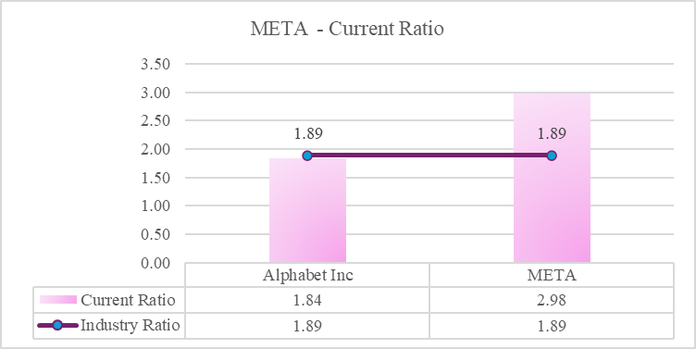

**Figure 5:** Current Ratio Chart

Meta has a higher current ratio of 2.98 (Investing.com, 2025a) compared to Alphabet Inc's 1.84 and the software and service industry average of 1.92 With a current ratio of 2.98 (Investing.com, 2025b), it reflects that Meta has healthy and strong liquidity to meet its short-term liabilities. A strong liquidity position can minimize/manage risks such as regulatory changes, market fluctuations, recessions, or any unexpected events.

Moreover, the strong liquidity position allows Meta to invest in R&D and company expansion as value-added activities. According to Meta Platforms, Inc. Form 10-K 2024, Meta's liquidity was used to procure costly $37.26 billion in properties and equipment to invest in data centers, servers, and other network infrastructure, as well as spending $9.75 billion to acquire marketable securities (meta-20241231, 2024). In contrast, Alphabet Inc. has a current ratio of 1.84, which is lower than the industry average of 1.92, indicating lesser liquidity in the software and service industry. According to Will Steward, a current ratio between 1.5 and 2.0 is still considered ideal for SaaS businesses (Steward, 2024); this indicates that Alphabet Inc. has enough cash to manage most of its short-term debt. However, if there are any market fluctuations or a recession, Alphabet Inc. will be more easily exposed to financial risks compared to Meta.

Meanwhile, Meta enhanced its cash ratio from 1.51 in 2022 to 2.32 in 2024, though it still falls short of the 4.41 achieved in 2020. The Covid-19 pandemic in 2020 severely affected Meta's finances, disrupting its advertising operations and hindering its ability to build, maintain, and scale its technological infrastructure. These financial strains introduced risks such as service interruptions, legal challenges, including class-action lawsuits, and other complications (Dybek, 2024). Based on the information above, it’s shown reason Meta holding high cash and caused high in current ratio, to prevent any force majeure and risks for business financial.

## **2.2.2 Net Profit Margin**

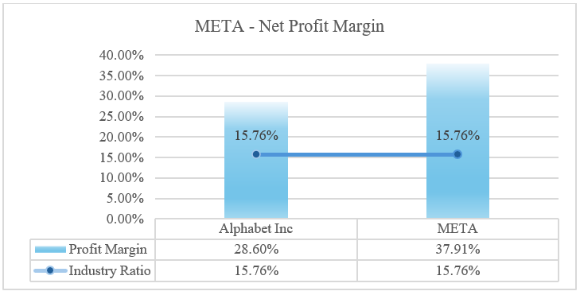

**Figure 6:** Net Profit Margin Chart

Meta’s (Investing.com, 2025a) profit margin of 37.91% indicates that it is more profitable compared to Alphabet Inc.'s 28.60% and the average in the software and service industry of 15.76% (Investing.com, 2025b). This suggests that Meta has an efficient business model, especially in advertising and social media services. The growth of Meta's revenue is gaining more market share from its advertising service and transforming its traditional advertising model on Facebook and Instagram into Reels (Meta's short-form video platform) to compete with TikTok. With this change, Meta successfully increased its active users by 7%; this user base increase provides a strong competitive edge compared to other advertising platforms such as Alphabet Inc.

In addition, the business recovered from its previous setbacks on implementing a strategy to increase investment in Metaverse and decrease advertising and restructured to concentrate on the development of artificial intelligence (AI) and cost-cutting measures, including the termination of several data center projects, the subleasing, early termination, or abandonment of a number of office buildings under operating leases, and the layoff of about 11,000 employees across the Family of Apps (FoA) and Reality Labs (RL) segments (Meta Platforms, Inc., 2025). By the end of the year, Meta AI is expected to surpass all other chatbots in usage, demonstrating the success of Meta's AI projects. The business also revealed impressive financial achievements, with revenue increasing by 25% in Q42023 and net income tripling to $14 billion. Additionally, Meta started paying dividends, which increased investor trust even more. With Meta’s momentum in AI and digital advertising, the analyst is still hopeful about Meta's development prospects in 2025 (Bowman, 2025a).

Moreover, some users and investors are disappointed with major players like Alphabet Inc. and Microsoft, which have made high investments in AI without resulting in a proportional increase in cloud segment margins (TipRanks, 2024).

## **2.2.3 Earnings per share (EPS)**

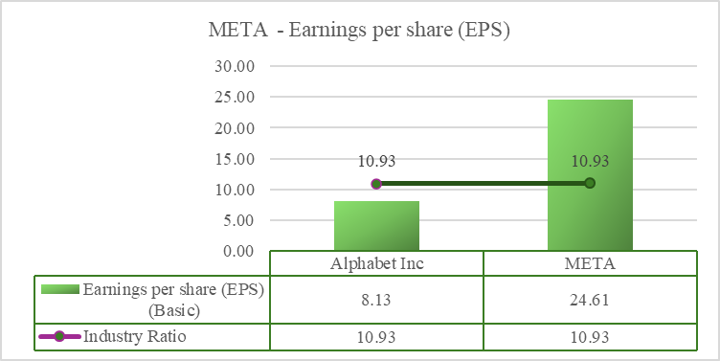

**Figure 7:** Earnings per share (EPS) Chart

Meta's has outperformed the earnings per share (EPS) of $23.86 (Investing.com, 2025a) compared with Alphabet Inc of $8.04 and industry average of $10.73 in 2024 (Investing.com, 2025b). As a leader in the tech sector, Alphabet Inc. prioritizes investments on cloud services, artificial intelligence, and research and development (R&D) (Simply Wall St, 2025) but in comparison with META's current ratio and profit margin, it indicates how well META's operational efficiency is in their business operation. During 2023, the META implemented cost-cutting projects budgeted $3.5 billion towards downsizing operations, resulting 22% of total workforce’s reduction. This aimed to contribute to enhanced profit margin and EPS (Dorsey, 2024). As mentioned above, META earned revenue growth from switching their digital advertising from Facebook and Instagram platform to Reels. Also, Meta’s has strategic investment in AI to strengthens user engagement and ad performance by experiencing Family of Apps, it has significant revenue grew 20.6% from Q4’23 to Q4’24, primary driven by online commerce (Hoi, 2025).

Meta modified its methods to sustain expansion despite regulatory obstacles in the US and the EU. By the end of 2023, there were 3.98 billion monthly active users (MAUs) across the company's apps, a 6% rise from the year before. 3.07 billion MAUs were on Facebook alone, a 3% increase from the previous year. Additionally, Meta entered developing regions including Africa and India, which should spur additional user growth and ad income (Lee, 2025).

Additionally, Meta's success was aided by the growing popularity of its AI-powered spectacles (Bowman, 2025b). By adding additional board members, such as UFC CEO Dana White, the corporation broadened its leadership to fortify its reputation and investigate expansion prospects. Analysts are nonetheless upbeat about Meta's prospects for expansion, pointing to its leadership in advertising and artificial intelligence (i.e., Meta AI and Llama) (Khan, 2025).

## **2.2.4 Conclusion for financial ratio analysis**

Due to expansion of strategies and strategic investments, Meta Platforms is anticipated to continue to have robust financial results in 2025. Analysts predicted that Meta's EPS will expand to $25.92, representing an 8.65% gain over 2024, and that its sales will reach roughly $192.28 billion, representing a 16.89% increase from 2024. It is projected that Meta's emphasis on AI and the metaverse would spur innovation and draw in new users and advertisers (Meta, 2024) (MarketBeat, 2025). Hence, we would like to recommend investing in META based on the financial analysis results presented above.

# **3.1 Stock Price Chart with Relevant Benchmark**

## **3.1.1 META’s Stock Price Analysis**

This analysis reviews META Inc.'s stock performance from January to December 2024, compared to the S&P 500. The report compares its stock price trends to the S&P 500 index which shows META's stock started In January 2024 opened at a level reflecting investors’ cautious optimism following Q4 earnings reports from late 2023(Bloomberg).

**Figure 8:** Meta Market Price 2024

A "golden cross" in June indicated by a 50-day short-term crossing, the 200-day long-term moving average marked a bullish shift. The MACD indicator confirmed divergence patterns that forecast the potential for continued upward momentum which reflect Meta’s outperformed in S&P 500 that gained 8–10% in 2024 (Yahoo Finance).

Strong Q1 earnings and AR product launches sparked mid-year momentum, with strategic partnerships enhancing META’s growth narrative. META diverged positively from Q2. META Inc. began showing signs of recovery with a breakout above the initial resistance levels witnessed in January and February. The technical signals included a rising trendline formed from the lows of February 2024 and a subsequent cross above the 100-day moving average in early May. We could significantly observe that the buying pressure in mid-April and mid-June in which there’s a recovery began in mid Q2 with a breakout above resistance levels and a rising trendline from May lows.

During Q3and Q4, we observe META’s sustaining an upward momentum with the stock attaining new 52-week highs as a bullish sign. The chart illustrates an accelerated price appreciation trend starting in early September. Near the end of the year, the stock closed near these all-time highs for 2024, although a slight pullback in the final weeks prompted by some technical uncertainty regarding the sustainability of the rally.

## **3.1.2 Conclusion for META’s stock price**

Over the same period, S&P 500 experienced moderate gains in line with broader market improvements supported by positive economic data. However, META’s trajectory outpaced the index from mid-year onward. Early in 2024 both stock and the exhibited comparable volatility, META’s began to resonate with investors, the company’s growth trajectory diverged positively from the broader market trend as their earnings surprises and strategic announcements. The gap between the two benchmarks is indicative not only of investor confidence for META Inc.'s transformative projects but also shows a sector rotation away from traditional blue-chip stocks towards technology and innovation-driven sector.

# **4.1 Leverage ratio**

## **4.1.1 Discussion**

In this Chapter, we analyze the financial leverage and capital structures of Meta Platforms Inc. (Meta), Apple Inc. (APPL), and Alphabet Inc. (Google) which provide a deep insight into the company’s debt and equity financing to indicate their financial stability and risk profiles. Meta, Alphabet and APPL are the leading industry which occupies the big portion of market cap. (Statista Report 2024.).

**Table 4.1:** Leverage Ratio for each company

|  |  |  |  |  |
| --- | --- | --- | --- | --- |
|  | **META** | **ALPHABET** | **APPL** | **Results** |
| Market Cap | 1.49 trillion | 2.32 trillion | 3.74 trillion |  |
| Debt-to-Assets Ratio | 18% | 6.25% | 32.6% | Apple Inc has higher reliance on debt to finance its assets among the competitors. |
| Debt-to-Equity Ratio | 27.20% | 8.65% | 209% | Apple Inc more relying on debt and will have large interest and principal payment to make on future. |
| Debt-to-Capital Ratio | 21.40% | 7.96% | 67.7% | Apple Inc is in high leverage also a large amount of debt relative to equity. |
| Debt-to-EBITDA Ratio | 59.50% | 21.70% | 88.4% | Alphabet’s (Google) has a positive EBITDA which means the company generates the profit and effectively manages the debt. |

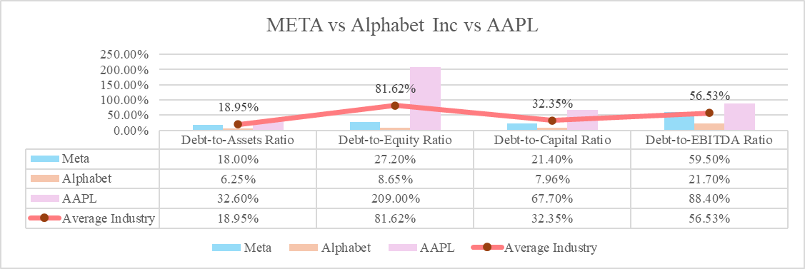

**Figure 9:** Comparison Graph for Leverage Ratio

Meta debt to asset ratio shows their moderate reliance on debt with financial stability which we could observe from Figure 9 that the leverage ratio of Meta’s was below the industry average. While the debt-to-equity ratio shows that $0.27 of debt for every $1 of equity indicates a strong equity base, providing resilience against financial uncertainties. Meanwhile, 21.4% of capital structure comprised of debt indicates a cautious approach to leveraging, balancing debt and equity to optimize capital costs while maintaining financial stability.​ 0.595 EBITDA ratio shows the effective management of debt relative to earnings that allowing for continued investment in business operations and growth initiatives. Hence, Meta's earnings are sufficient to cover its debt obligations comfortably. Despite Meta's high leverage ratio, investors remain drawn to the company due to its strong AI-driven growth potential with heavily investing in AI infrastructure come with their robust operating margins that has made them valuable.

However, from Figure 9 above we could observe that APPL could imply an increase in financial risk as their leverage ratio was higher than the average industry ratio especially when the company faces challenges in generating sufficient cash flows to meet its debt obligations. Besides, 2.09 of debt-to-equity ratio reveals a heavy reliance on debt with twice of debt for every $1 of equity. This ratio reflects financial instability in substantial risk profile as the company is more obligated to meet fixed debt commitments.​ APPL’s reliance on debt could lead to increased financial vulnerability, particularly if the company encounters operational challenges which 67.7% of APPL’s capital is debt. The EBITDA ratio by APPL’s could be consider as a strong financial standing although it is slightly higher that both other companies. In May 2024, APPL have authorised a record-breaking share repurchase with 110million US Dollar which is the major cause for their debt announced in 2024 as 119.1million dollar. This represent that exact annual debt after deducting the 110 million of share buybacks cost will be 9.1 million that reflects their company is relatively profitable and strong financial strength. Hence, although APPL’s debt ratio might appear high, investors are still attracted to the company due to its strong brand, consistent profitability, and dividend payouts which outweigh the perceived risks associated with its leverage. APPL remain attractive as the consistent profitability with strong branding and ecosystems.

In a nutshell, Alphabet’s Leverage ratio which significantly below of industry ratio proven their strong financial performance with only 6.25% of Alphabet's assets are financed through debt. This low leverage enhances financial flexibility and reduces risk exposure. Alphabet demonstrates a robust equity position of utilizing only $0.0865 of debt per dollar of equity reflects a strong financial foundation and lower financial risk. Out of its capital, only 7.96% comes from debt, which minimizes the financial risk and enhances the company’s ability to invest without substantial debt constraints. Besides, their EBITDA ratio of 0.217 reflects a strong ability to manage and repay its debt through their earnings. This indicates that the company's earnings before interest, taxes, depreciation, and amortization are significantly higher than its total debt proving its financial robustness. Lastly, in an investment view, Alphabet’s have factors as their strong fundamentals and high growth potential come along with successful proven track-record will also outweigh their perceived risk of a leverage ratio.

In conclusion, both Meta and Alphabet primarily finance their operations through equity, maintaining low debt levels to minimize financial risk. Meta's recent $10.5 billion bond issuance in August 2024 was aimed at general corporate purposes, reflecting strategic use of debt in favorable market conditions. APPL’s financial strength should be reconsidered as the debt amount was included with its own share buybacks that highly affect the statistical accuracy and actual performance of APPL.

## **4.1.2 Conclusion for leverage ratio**

In evaluating these capital structures, Meta's provides a balanced approach to debt and equity financing, maintaining moderate leverage that supports growth while ensuring both operational flexibility and financial health. Alphabet maintains a conservative capital structure with minimal debt reliance which reflecting a strong equity base and low financial risk. The minimal debt that underscores a robust financial position offer the company significant flexibility for future investments and growth initiatives.

Finally, Apple’s was slightly reliance on debt financing according to its higher leverage ratios in 2024 due to their significantly high shares buybacks amount. Apple Inc. still withstands a good debt to EBITDA ratio that indicates a strong financial standing after 110 million shares repurchase. Hence, according to the analysis we fully agree with APPL’s capital structure.

# **5.1 Recommendation/Self Reflection**

We learned that Meta Platforms, Inc. is a global technology leader that has evolved from a social networking site into a multifaceted company driving innovation in social media, virtual reality, and the metaverse. As Meta continues to position itself at the forefront of technological innovation particularly through its investments in artificial intelligence and the metaverse, it must also remain critically aware of the ethical, regulatory, and societal challenges that accompany such rapid expansion. To ensure sustainable growth and long-term stakeholder trust, it is recommended that Meta strengthen its commitment to transparency, responsible innovation, and inclusive digital governance. Balancing innovation with accountability will be key to maintaining its competitive edge and securing its role in the future of global digital interaction.

Based on my personal findings and analysis on META’s 5-year financial statements and balance sheets, I would recommend investing in META’s stocks because it offers solid prospects for long-term growth; the company reacted quickly to the market trend and took action to make the necessary changes in accordance with the market changes and needs. It is a worth investing company as such. I did not know accounting in the past. After I did the group assignment, I came to learn the importance of accounting and finance in our life; it does not just apply to a company, but also to countries, as well as individuals. We must not only look at revenue and income, but also at our personal liabilities(spendings/installments/mortgage/loan); overspending on the unnecessaries would expose us to the risk financial crisis, just like any companies/countries do. I have benefited a lot from this course.

The latest U.S. tariffs and implications may indirectly impact on Meta on supply chain costs which is the U.S. tariffs on Chinese imports, which reached up to 145%, could increase the costs for Meta’s hardware production, such as Virtual Reality (VR) headsets and smart glasses (Sexton et al., 2025). Retaliatory tariffs from China, up to 125% may further disrupt the supply chain (Stevenson, 2025).

According to financial ratio analysis, we found that uncertainty of financial risk among software and service industry recent years especially after Covid-19 pandemic, which impacting Meta’s advertising business, limited ability to build, maintained and scale their technical infrastructure, which bring the risks associated with disruption in Meta’s service, as well as litigation, included class action lawsuit, and so on. Based on findings, it’s shown reason software and service industry need holding high cash ratio, to prevent any force majeure and risks for business financial.

Additionally, new rivals like China-based AI firm Deep Seek, which has created affordable AI models, pose a threat to Meta. In contrast to Meta's substantial investment in its Llama AI systems, Deep Seek develops AI models at a low cost. The rivalry might affect Meta's hegemony in the AI market (Baccardax, 2025).

Therefore, maintaining Meta's expansion plan should depend on its capacity to leverage its investments and adjust to competition forces (Baccardax, 2025).

Over the same period, S&P 500 experienced moderate gains in line with broader market improvements supported by positive economic data. However, META’s trajectory outpaced the index from mid-year onward. Early in 2024 both stock and the exhibited comparable volatility, META’s began to resonate with investors, the company’s growth trajectory diverged positively from the broader market trend as their earnings surprises and strategic announcements. The gap between the two benchmarks is indicative not only of investor confidence for META Inc.'s transformative projects but also shows a sector rotation away from traditional blue-chip stocks towards technology and innovation-driven sector.

While conducting financial analysis among the companies, I get valuable insight on how the tech companies (Meta, Google, Appple) manage their capital structure in a strategic way. “Numbers don’t lie, but don’t tell the whole truth” and this statement can reflect on my research, it makes me realize that we must understanding the story behind and to see the bigger picture of the companies instead of just interpret financial data based on annual report.

Through this analysis of the U.S. government's FY 2024 financial report, I have learned how deeply interconnected revenue, spending, and debt are in determining the nation’s fiscal health. I now better understand how rising entitlement costs, surging interest payments, and growing federal debt contribute to long-term financial instability, especially when revenue growth is unable to keep up. The large and increasing budget deficit, negative net position, and unsustainable debt projections signal an urgent need for reform. Based on this understanding, I recommend that the government take a balanced approach by implementing targeted spending reductions, particularly in areas with inefficiencies like defense and entitlement programs, while also pursuing tax reforms to boost revenue, such as eliminating corporate loopholes and ensuring fairer tax contributions. Additionally, long-term investments in infrastructure and innovation, supported through public-private partnerships, can stimulate economic growth and help reduce the debt burden over time.

# **6.1 Analysis of US Government Financial Report**

The financial operations of the United States for Fiscal Year (FY) 2024 offer important insights into the country’s long-term financial sustainability. Analyzing the U.S. government’s budget deficit, income statement, balance sheet, and key financial metrics reveals significant challenges in the nation’s spending, revenue generation, and debt management.

## **6.1.1 Operating Cost and Budget Deficit**

In FY 2024, the U.S. government had a budget deficit of **1,800 billion dollars**, up by **137.6 billion dollar**s (8.1%) from the previous year. This deficit accounted for 6.4% of GDP, an increase from 6.2% in FY 2023, signaling a widening gap between spending and revenue. The deficit grew mainly due to a 10% rise in government spending, reaching **6,700 billion dollars**, driven by higher interest payments on federal debt and increased entitlement spending like Social Security and Medicare. Although revenue increased by 11% to **4,900 billion dollars**, it was not enough to cover the higher costs. A major concern was the 34% surge in net interest payments, which hit **882 billion dollars**, surpassing defense spending. This reflects the rising cost of servicing national debt, which continues to grow due to increased borrowing.

## **6.1.2 Income Statement**

In FY 2024, the U.S. government’s gross costs totaled **7,800 billion dollars**. After accounting for **653 billion dollars** in revenues from services like Medicare and national parks, and **284 billion dollars** in net losses from financial changes (such as interest rates and inflation), the net cost was **7,400 billion dollars**. This was a **479.9 billion dollar** (6.1%) decrease from FY 2023. The reduction was mainly due to lower losses from estimates on employee and veteran benefits, though these savings were partly offset by higher interest costs on federal debt. This shows progress in reducing some liabilities, but the burden of debt servicing remains a major challenge.

## **6.1.3 Revenue and Taxation**

The government collected **$5.0 trillion in total revenue** in FY 2024, an **11.5% increase ($512.3 billion)** from the previous year. This growth was mainly fueled by higher individual and corporate income taxes, which made up **over 92% of total revenues**. Other revenue sources included excise taxes, customs duties, and earnings from the Federal Reserve. Despite this increase, revenue growth still lagged expenditure growth, contributing to the persistent budget deficit. The widening gap between revenue and spending highlights the need for both revenue enhancements and cost containment.

## **6.1.4 Balance Sheet**

As of September 30, 2024, the U.S. government had **5,700 billion dollars** in assets and **45,500 billion dollars** in liabilities, resulting in a negative net position of **39,900 billion dollars**. The government's assets include **1,800 billion dollars** in loans and **1,300 billion dollars** in infrastructure. However, its liabilities are much higher, with **28,300 billion dollars** in federal debt and **15,000 billion dollars** in benefits owed to federal employees and veterans. This large gap between assets and liabilities highlights the challenge of managing debt and future obligations, emphasizing the need for fiscal reforms.

**6.1.5 Summary of Key Financial Metrics**

**Table 6.1:** “Nation by Numbers” Table

|  |  |
| --- | --- |
| **Financial Metric** | **Amount (in billion dollars)** |
| Total Gross Costs | 7,800 |
| Revenues from Goods & Services | 653 |
| Net Losses from Assumptions | 284 |
| **Net Cost** | **7,400** |
| Total Tax and Other Revenues | 5,000 |
| **Net Operating Cost** | **2,400** |
| Total Assets | 5,700 |
| Total Liabilities | 45,500 |
| **Net Position** | **(39,900)** |

***Source****:* U.S. Department of the Treasury, Bureau of the Fiscal Service (2024)

The U.S. government generates most of its income through taxation. In FY 2024, total tax revenues, including individual income taxes, corporate taxes, and social insurance contributions, amounted to **4,900 billion dollars**, reflecting an 11% increase from the previous year. However, this increase in revenue is still insufficient to cover the rising costs of government operations. Major areas of spending include **Social Security**, **Medicare**, and **defense**, along with escalating interest payments on the national debt. In FY 2024, interest expenses alone accounted for **882 billion dollars**, making it one of the largest components of government spending. To finance its operations and cover the budget deficit, the U.S. government borrows from the public, with federal borrowing increasing by **2,000 billion dollars** in FY 2024, bringing the total debt held by the public to **28,200 billion dollars**. This growing debt poses a concern for future generations, as it could limit the government’s ability to allocate funds to other essential areas such as education, healthcare, and infrastructure. Additionally, the government’s assets include physical assets like infrastructure and loans receivable, but its liabilities, particularly public debt and obligations to federal employees and veterans, far exceed its assets, resulting in a substantial negative net position of **39,900 billion dollars**. This imbalance suggests that the U.S. government’s financial position is becoming more precarious, and without changes to reduce debt and manage future liabilities, long-term fiscal sustainability may be at risk.

## **6.1.6 Debt and Long-Term Obligations**

The government’s **total federal debt reached $28.3 trillion**, up by **$2.0 trillion** from FY 2023. When combined with **$7.1 trillion in intra-governmental debt**, the burden of borrowing becomes even more evident. These rising debt levels reflect the continued use of borrowing to finance operating deficits, especially in the absence of structural reform. Long-term liabilities, including Social Security and Medicare obligations, continue to grow faster than revenues. Over the next 75 years, the government is projected to spend **$72.7 trillion more than it collects**, excluding interest—a clear indicator of fiscal unsustainability.

## **6.1.7 Fiscal Sustainability and Projections**

The government’s fiscal trajectory remains troubling. Under current policies, the **debt-to-GDP ratio is projected to rise from 98% in 2024 to an unsustainable 535% by 2099**. The **primary deficit** (excluding interest) was **3.3% of GDP** in FY 2024 and is expected to average **3.1% over the next decade**. These deficits are mainly driven by aging-related expenses, especially Social Security and Medicare. To return to a sustainable path, the U.S. would need to close a fiscal gap of **4.3% of GDP over 75 years**, through spending cuts, tax increases, or both. Delaying reforms until 2045 would increase the needed adjustment to **6.3% of GDP**, placing a greater burden on future generations.

## **6.1.8 Net Position and Cash Flow**

Although the government has adequate short-term liquidity to meet current obligations, its **long-term financial position is deteriorating**. With a negative net position of **$39.9 trillion**, largely driven by debt and unfunded benefit promises, the fiscal foundation remains unstable. Interest costs are rising, revenue is insufficient to match expenditure, and reliance on borrowing continues to grow. This highlights the urgency of implementing meaningful reforms to restore fiscal health.

## **6.1.9 Conclusion**

The U.S. government's financial report for FY 2024 reveals significant challenges, including a rising **budget deficit**, **debt levels**, and e **interest costs**, with a **negative net position** of **39,900 billion dollars**. To improve fiscal health, the government should focus on reducing the deficit by cutting discretionary spending, especially in defense, and addressing inefficiencies in programs like Medicare and Social Security. Tax reforms, such as closing corporate tax loopholes and implementing a more progressive tax system, could boost revenue. Additionally, a clear debt reduction strategy, investment in economic growth through technology and infrastructure, and reviewing federal employee benefits for sustainability can help reduce long-term liabilities. Leveraging **public-private partnerships (PPPs)** for infrastructure projects can also ease financial burdens. Implementing these measures would ensure long-term fiscal stability and improve the nation’s financial situation.

# **7.0 References**

1. Abueid, A. I., Mohammad, S. I., Mohammad, A. a. S., Vasudevan, A., Sarayreh, A. A., Alrfai, M. M., Aldaihani, F. M. F., Al-Momani, A. M., & Saraireh, S. (2025). Digital finance and fintech innovations towards disrupting finance innovation. In *Studies in computational intelligence* (pp. 17–31). https://doi.org/10.1007/978-3-031-77925-1_2
2. Baccardax, M. (2025). *Meta Platforms earnings reveal surprising 2025 forecast*. [online] TheStreet. Available at: <https://www.thestreet.com/investing/stocks/meta-earnings-includes-surprising-2025-outlook-amid-deepseek-challenge> [Accessed 11 Apr. 2025].
3. Bowman, J. (2025a). *Why Meta Platforms Stock Jumped 65% in 2024*. [online] Nasdaq.com. Available at: <https://www.nasdaq.com/articles/why-meta-platforms-stock-jumped-65-2024> [Accessed 11 Apr. 2025].
4. Bowman, J. (2025b). *Why Meta Platforms Stock Jumped 65% in 2024*. [online] Yahoo Finance. Available at: https://finance.yahoo.com/news/why-meta-platforms-stock-jumped-215017727.html [Accessed 11 Apr. 2025].
5. Dixon, Stacy Jo (2025). *META: annual advertising revenue worldwide 2009-2024*. [online] Available at: <https://www.statista.com/statistics/271258/facebooks-advertising-revenue-worldwide/> [Accessed 04 Apr. 2025].
6. Dorsey, C. (2024). *How Meta’s Recent Layoffs Made A Big Impact On Profits*. [online] Yahoo Finance. Available at: <https://finance.yahoo.com/news/meta-recent-layoffs-made-big-165309713.html> [Accessed 05 Apr. 2025].
7. Dybek, M. (2024). *Meta Platforms Inc. (NASDAQ:META) | Analysis of Liquidity Ratios*. [online] Stock Analysis on Net. Available at: <https://www.stock-analysis-on.net/NASDAQ/Company/Meta-Platforms-Inc/Ratios/Liquidity#Ratios-Summary> [Accessed 05 Apr. 2025].
8. Gazi, M. A. I., Islam, H., Islam, M. A., Karim, R., Momo, S. M., & Senathirajah, A. R. B. S. (2024). Unlocking sustainable development in East Asia Pacific and South Asia: An econometric exploration of ESG initiatives. Sustainable Environment, 10(1), 2366558.
9. Hoi, S.C. (2025). *Meta Q4 2024 earnings call: Strong revenue growth amid AI investments*. [online] The Fifth Person. Available at: <https://fifthperson.com/meta-q4-2024-earnings-call/?utm_source=chatgpt.com> [Accessed 10 Apr. 2025].
10. Investing.com (2025a). *Facebook (FB) Financial Ratios*. [online] Investing.com. Available at: <https://www.investing.com/equities/facebook-inc-ratios> [Accessed 11 Apr. 2025].
11. Investing.com (2025b). *Alphabet Inc. (GOOGL) Financial Ratios*. [online] Investing.com. Available at: <https://www.investing.com/equities/google-inc-ratios> [Accessed 11 Apr. 2025].
12. Johnston, M. (2024). *How Does Facebook (Meta) Make Money?* [online] Investopedia. Available at <https://www.investopedia.com/ask/answers/120114/how-does-facebook-fb-make-money.asp> (Accessed: 04 Apr 2025)
13. khan, N. (2025). *Meta’s Stock Surges 65% in 2024 as Zuckerberg Sells Millions in Shares*. [online] Yahoo Finance. Available at: <https://finance.yahoo.com/news/metas-stock-surges-65-2024-160834031.html> [Accessed 11 Apr. 2025].
14. Lee, M. (2025). *Meta Platforms Stock Soared 65% in 2024: Here’s Why*. [online] Ainvest. Available at: <https://www.ainvest.com/news/meta-platforms-stock-soared-65-in-2024-here-s-why-2501101090db04654edcfb42/> [Accessed 11 Apr. 2025].
15. Levy, A (2022). *5 Factors That Led to META Platforms First Revenue Decline.* [online] Available at: <https://www.nasdaq.com/articles/5-factors-that-led-to-meta-platforms-first-revenue-decline> [Accessed 04 Apr. 2025].
16. Meta (2021). *Introducing Meta: a Social Technology Company*. [online] Meta. Available at: <https://about.fb.com/news/2021/10/facebook-company-is-now-meta/>. [Accessed 05 Apr. 2025].
17. Meta (2024a). *Meta Quest VR Headsets, Accessories & Equipment | Meta Quest*. [online] www.meta.com. Available at: <https://www.meta.com/quest/> [Accessed 05 Apr. 2025].
18. Meta (2024b). *Facebook Careers | Do the Most Meaningful Work of Your Career*. [online] Facebook Careers. Available at: <https://www.metacareers.com/> [Accessed 05 Apr. 2025].
19. Meta (2024c). *We’re committed to keeping people safe and making a positive impact. | Meta*. [online] We’re committed to keeping people safe and making a positive impact. Available at: <https://about.meta.com/actions/> [Accessed 05 Apr. 2025].
20. Meta Platforms, Inc. (2025). *Annual Report 2024*. [online] Available at: <https://d18rn0p25nwr6d.cloudfront.net/CIK-0001326801/a8eb8302-b52c-4db5-964f-a2d796c05f4b.pdf>. [Accessed 11 Apr. 2025].
21. Sec.gov. (2024). *meta-20241231*. [online] Available at: <https://www.sec.gov/Archives/edgar/data/1326801/000132680125000017/meta-20241231.htm>
22. Simply Wall St (2025). *Alphabet Full Year 2024 Earnings: In Line With Expectations*. [online] Simply Wall St. Available at: https://simplywall.st/stocks/us/media/nasdaq-googl/alphabet/news/alphabet-full-year-2024-earnings-in-line-with-expectations [Accessed 11 Apr. 2025].
23. Statista (2024). *The Statistics Portal for Market data, Market Research and Market Studies*. [online] Statista.com. Available at: <https://www.statista.com/> [Accessed 5 Apr. 2025].
24. Steward, W. (2024). *The Current Ratio and Quick Ratio: a Guide for SaaS Founders*. [online] Cobloom.com. Available at: [https://www.cobloom.com/blog/current-ratio-quick-ratio-for-saas-founders#](https://www.cobloom.com/blog/current-ratio-quick-ratio-for-saas-founders) [Accessed 05 Apr. 2025].
25. The Verge (2019). *The Verge*. [online] The Verge. Available at: <https://www.theverge.com/> [Accessed 05 Apr. 2025].
26. TipRanks (2024). *Why Meta Platforms Stock (NASDAQ:META) Outperformed Big Tech This Earnings Season*. [online] Yahoo Finance. Available at: https://finance.yahoo.com/news/why-meta-platforms-stock-nasdaq-224838583.html [Accessed 05 Apr. 2025].
27. U.S. Department of the Treasury, Bureau of the Fiscal Service. (2024). *Financial Report of the United States Government: Fiscal Year 2024*. [online] Available at: <https://fiscal.treasury.gov/reports-statements/financial-report/> [Accessed 08 Apr. 2025].
28. Yahoo Finance, (2024a). *Meta Platforms, Inc. (META) Company Profile & Facts - Yahoo Finance*. [online] Available at: <https://finance.yahoo.com/quote/META/profile/> [Accessed 06 Apr. 2025].
29. Yahoo Finance, (2024b). *Meta Platforms, Inc. (META) Income Statement - Yahoo Finance*. [online] Available at: <https://finance.yahoo.com/quote/META/financials/> [Accessed 06 Apr. 2025].