A Study to Assess the Patient's Perception and Level of Satisfaction Towards Nursing Care Delivery at Tertiary Care Hospital, in Western U.P

Vaishali Gill¹, Mr. Sanjay Saini², Prof. Dr. S. Balamani Bose³*
¹M.Sc Nursing (Mental Health Nursing) College of Nursing, LLRM Medical College, Meerut, U.P.
² Assistant Professor, College of Nursing, L.L.R.M Medical College, Meerut, U.P.
^{3*}Principal, College of Nursing, L.L.R.M Medical College, Meerut, U.P.

*Corresponding Author: Prof. (Dr.) S. Balamani Bose
Principal, College of Nursing, LLRM Medical College, Meerut, Uttar Pradesh, India. balabosejeeva@gmail.com

ABSTRACT
Background: Nursing care plays a pivotal role in healthcare delivery as it directly influences patient recovery and satisfaction. This study assesses patients’ perception and satisfaction towards nursing care delivery in a tertiary care hospital in Western Uttar Pradesh.
Objectives: (a) To assess patient perception of nursing care. (b) To measure satisfaction with nursing services. (c) To identify factors affecting patient satisfaction. (d) To compare satisfaction across demographics.
Methodology: A mixed research approach (convergent parallel design) was adopted. A purposive sample of 120 admitted patients was selected. Tools included a standardized Patient Satisfaction with Nursing Care Quality Questionnaire and a self-structured questionnaire. Data analysis was done using descriptive and inferential statistics.
Results: The majority of patients (80%) were moderately satisfied with nursing care. Communication and attentiveness were appreciated, while hygiene and infrastructure required improvement. No significant association was found between satisfaction levels and demographic variables.
Conclusion: Nursing care was perceived as adequate, with areas for improvement in hygiene and communication. Findings highlight the need for continuous quality improvement and patient-centered approaches in tertiary care.
Keywords: Patient perception, Satisfaction, Nursing care, Health outcomes, Tertiary care hospital.

INTRODUCTION
Nursing care is a cornerstone of healthcare delivery, influencing recovery trajectories and patient satisfaction. In tertiary hospitals, where complex cases are treated, patient- centered nursing care is vital. This study explores patients' perception and satisfaction with nursing services at SVBP Hospital, Meerut, aiming to identify strengths and gaps.

METHODOLOGY
Research Approach: Mixed method, convergent parallel design.
Setting: SVBP Tertiary Care Hospital, Meerut.
Sample: 120 adult inpatients selected through purposive sampling. Instruments: (a) Patient Satisfaction with Nursing Care Quality Questionnaire (PSNCQQ). (b) Self-structured questionnaire for patient perception.
Reliability: Pearson correlation coefficient = 0.82; Spearman-Brown = 0.90 (high reliability).
Ethical Considerations: Institutional approval and informed consent were obtained.

RESULTS
Findings showed that most patients were young (61.7% aged 21–40), married (71.7%), and from low-income groups. Overall, 80% reported moderate satisfaction with nursing care. Strengths included attentiveness and communication, while weaknesses included hygiene and infrastructure. Chi-square tests showed no significant association between satisfaction levels and demographic variables.

Section 1: Description of the demographic variables of the subjects.
It deals with demographic data which consists of 11 items to collect the sample characteristics, which comprises Age (in actual year), Gender, Marital status, education qualification, Occupation, income level (Per month in rupees) type of admission, duration of hospital stay, previous experience with healthcare facilities, place of residence, type of ward.

Table- 1: Distribution of respondent according to Age (in actual years)

(N=120)
Age (in years) | Frequency | Percentage
18-20Yrs | 12 | 10.0%
21-40Yrs | 74 | 61.7%
40-60Yrs | 30 | 25.0%
61-75Yrs | 4 | 3.3%
Total | 120 | 100%

Table- 2: Distribution of respondent according to Gender

(N=120)
Gender | Frequency | Percentage
Female | 61 | 50.8%
Male | 59 | 49.2%
Total | 120 | 100%

Table- 3: Distribution of respondent according to Marital status

(N=120)
Marital status | Frequency | Percentage
Married | 86 | 71.7%
Other Specific | 3 | 2.5%
Single | 31 | 25.8%
Total | 120 | 100%

Table- 4: Distribution of respondent according to Education qualification

(N=120)
Education qualification | Frequency | Percentage
Graduate | 13 | 10.8%
Illetrate | 24 | 20.0%
Postgraduate and above | 4 | 3.3%
primary | 44 | 36.7%
Secondary | 35 | 29.2%
Total | 120 | 100%

Table- 5: Distribution of respondent according to occupation (N=120)
Occupation | Frequency | Percentage
Business | 16 | 13.3%
Government employed | 2 | 1.7%
Labour | 52 | 43.3%
Private employed | 4 | 3.3%
Unemployed | 46 | 38.3%
Total | 120 | 100%

Table- 6: Distribution of respondent according to Income level (per month in rupees)

(N=120)

Income level (per month in rupees) | Frequency | Percentage
10,001–20000 | 51 | 42.5%
20,001–50000 | 7 | 5.8%
Below 10,000 | 62 | 51.7%
Total | 120 | 100%
Table- 7: Distribution of respondent according to type of admission

(N=120)
Type of admission | Frequency | Percentage
Referral | 38 | 31.7%
Under trial | 3 | 2.5%
Voluntary | 79 | 65.8%
Total | 120 | 100%

Table- 8: Distribution of respondent according to duration of hospital stay

(N=120)

Duration of hospital stay | Frequency | Percentage
1–2 weeks | 37 | 30.8%
2–4 weeks | 14 | 11.7%
Less than 1 week | 69 | 57.5%
Total | 120 | 100%

Table- 9: Distribution of respondent according to previous experience with healthcare facilities

(N=120)

Previous experience with healthcare facilities | Frequency | Percentage
First-time patient | 95 | 79.2%
Recurrent patient | 25 | 20.8%
Total | 120 | 100%

Table- 10: Distribution of respondent according to place of residence

(N=120)

Place of Residence | Frequency | Percentage
Rural | 55 | 45.8%
Urban | 65 | 54.2%
Total | 120 | 100%

Table- 11: Distribution of respondent according to Types of Ward

(N=120)

Types of Ward | Frequency | Percentage
General | 89 | 74.2%
Private | 12 | 10.0%
Special | 19 | 15.8%
Total | 120 | 100%

Table- 12: Distribution of respondent according to Age (in actual years)

(N=120)
Age (in years) | Frequency | Percentage
18-20Yrs | 12 | 10.0%
21-40Yrs | 74 | 61.7%
40-60Yrs | 30 | 25.0%
61-75Yrs | 4 | 3.3%
Total | 120 | 100%

Table- 13: Distribution of respondent according to Gender

(N=120)
Gender | Frequency | Percentage
Female | 61 | 50.8%
Male | 59 | 49.2%
Total | 120 | 100%

Table- 14: Distribution of respondent according to Marital status

(N=120)
Marital status | Frequency | Percentage
Married | 86 | 71.7%
Other Specific | 3 | 2.5%
Single | 31 | 25.8%
Total | 120 | 100%

Table- 15: Distribution of respondent according to Education qualification

(N=120)
Education qualification | Frequency | Percentage
Graduate | 13 | 10.8%
Ill etrate | 24 | 20.0%
Postgraduate and above | 4 | 3.3%
primary | 44 | 36.7%
Secondary | 35 | 29.2%
Total | 120 | 100%

Table- 16 : Distribution of respondent according to occupation

(N=120)
Occupation | Frequency | Percentage
Business | 16 | 13.3%
Government employed | 2 | 1.7%
Labour | 52 | 43.3%
Private employed | 4 | 3.3%
Unemployed | 46 | 38.3%
Total | 120 | 100%

Table- 17: Distribution of respondent according to Income level (per month in rupees)

(N=120)
Income level (per month in rupees) | Frequency | Percentage
10,001–20000 | 51 | 42.5%
20,001–50000 | 7 | 5.8%
Below 10,000 | 62 | 51.7%
Total | 120 | 100%

Table- 18: Distribution of respondent according to type of admission

(N=120)
Type of admission | Frequency | Percentage
Referral | 38 | 31.7%
Under trial | 3 | 2.5%
Voluntary | 79 | 65.8%
Total | 120 | 100%

Table- 19: Distribution of respondent according to duration of hospital stay

(N=120)
Duration of hospital stay | Frequency | Percentage
1–2 weeks | 37 | 30.8%
2–4 weeks | 14 | 11.7%
Less than 1 week | 69 | 57.5%
Total | 120 | 100%

Table- 20: Distribution of respondent according to previous experience with healthcare facilities

(N=120)
Previous experience with healthcare facilities | Frequency | Percentage
First-time patient | 95 | 79.2%
Recurrent patient | 25 | 20.8%
Total | 120 | 100%

Table- 21: Distribution of respondent according to place of residence

(N=120)
Place of Residence | Frequency | Percentage
Rural | 55 | 45.8%
Urban | 65 | 54.2%
Total | 120 | 100%

Table- 22: Distribution of respondent according to Types of Ward

(N=120)
Types of Ward | Frequency | Percentage
General | 89 | 74.2%
Private | 12 | 10.0%
Special | 19 | 15.8%
Total | 120 | 100%

Section 2: Findings related to patient perception on nursing care.

- Regarding assessing the overall quality of care and services received during their hospital stay,
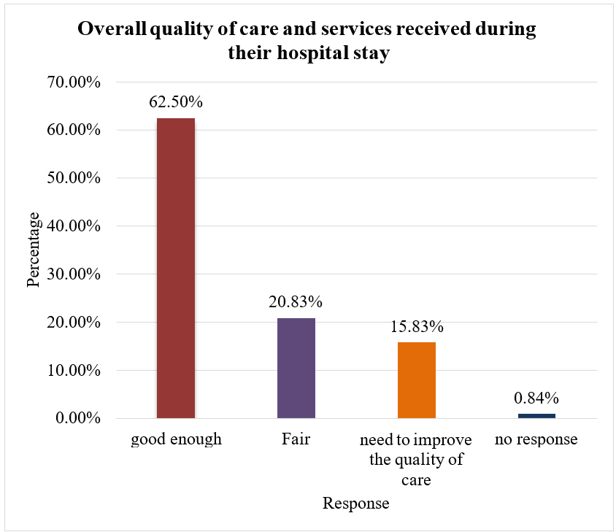
Figure A: Overall quality of care and services received during their hospital stay

- Regarding evaluating the general health status of patients following their hospital stay,
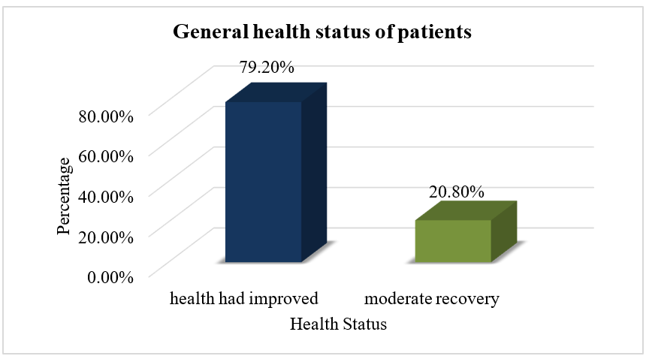
Figure B: General health status of patients
Section 3: Findings related to Measure the Patient Satisfaction with Nursing Care.
Table 23: Findings related to patient satisfaction score with Nursing Care

(N=120)
Group | Max Score | Mean | Mean % | SD
Patient perception | 95 | 55.99 | 58.93 | 10.57

Table 24: Findings related to patient satisfaction level with Nursing Care

(N=120)
Sl. No | Patient satisfaction level | Score | F | %
1. | Low Satisfaction | 19 to 44 | 16 | 13.3%
2. | Satisfied | 45 to 69 | 96 | 80.0%
3. | Highly satisfied | 70 to 95 | 8 | 6.7%
Total |  |  | 120 | 100%

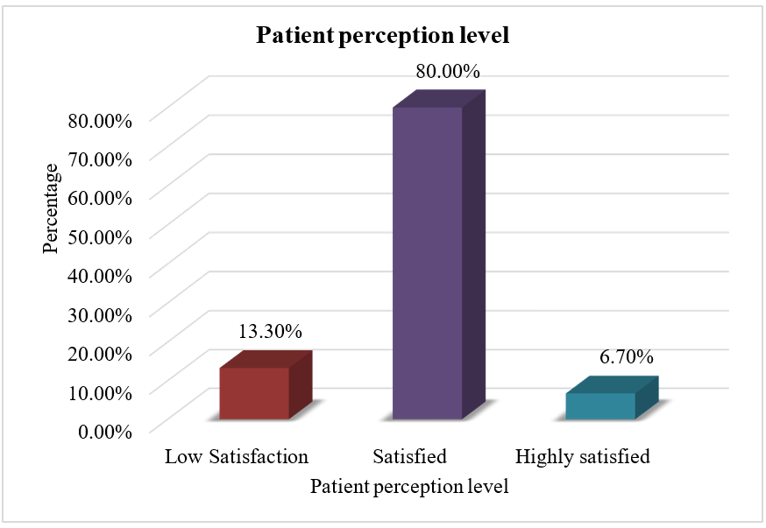
Figure- C: Distribution of respondent by patient satisfaction level with Nursing Care

Section 4: Findings related to Factors Affecting Patient Satisfaction with Nursing Care.

- When asked to suggest improvements to nursing care at the hospital, patient responses highlighted several key areas.
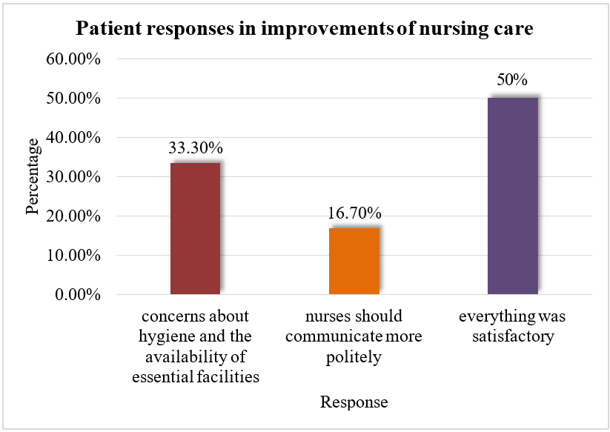
Figure D: Patient responses in improvements of nursing care

- Regarding response to an open-ended question about additional comments, concerns, or suggestions regarding nursing care,
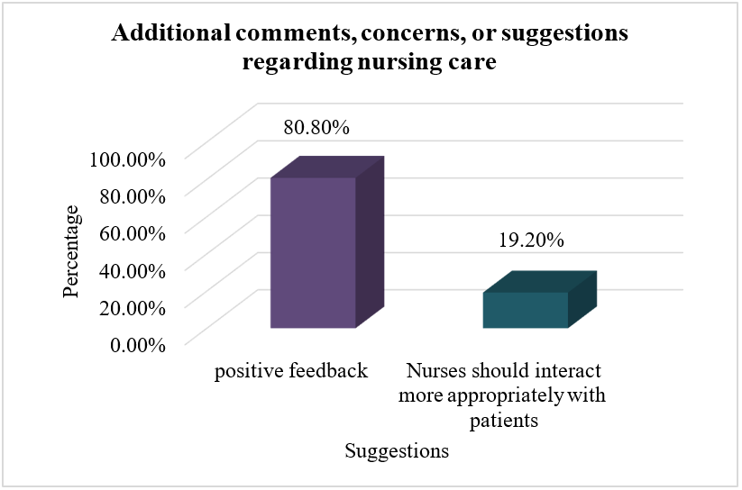
Figure E : Additional comments, concerns, or suggestions regarding nursing care Section 5: Deals with compare Patient Satisfaction across Different Demographics.

Table 25 - Deals with compare Patient Satisfaction across Different Demographics.

(N=120)
Variable |  | Highly |  |  |  | Low |  |  |  | Satisfied |  |  |  | Df |  |  |  | Chi- square  value |  |  |  | P  value |  |  |  | Inference
Age in year
18-20Yrs | 1 |  |  |  | 2 |  |  |  | 9 |  |  |  | 6 |  |  |  | 3.008 |  |  |  | 0.808 |  |  |  | NS
21-40Yrs | 5 |  |  |  | 7 |  |  |  | 62
40-60Yrs | 2 |  |  |  | 6 |  |  |  | 22
Variable |  | Highly |  |  |  | Low |  |  |  | Satisfied |  |  |  | Df |  |  |  | Chi-  square value |  |  |  | P  value |  |  |  | Inference
61-75Yrs |  | 0 |  |  |  | 1 |  |  |  | 3
Total |  | 8 |  |  |  | 16 |  |  |  | 96
Gender
Female |  |  |  | 3 |  |  |  | 4 |  |  |  | 54 |  |  |  | 2 |  |  |  | 5.968 |  |  |  | 0.051 |  |  |  | NS
Male |  |  |  | 5 |  |  |  | 12 |  |  |  | 42
Total |  |  |  | 8 |  |  |  | 16 |  |  |  | 96
Marital status
Married |  |  |  | 5 |  |  |  | 13 |  |  |  | 68 |  |  |  | 4 |  |  |  | 3.055 |  |  |  | 0.549 |  |  |  | NS
Other Specific |  |  |  | 0 |  |  |  | 1 |  |  |  | 2
Single |  |  |  | 3 |  |  |  | 2 |  |  |  | 26
Total |  |  |  | 8 |  |  |  | 16 |  |  |  | 96
Education qualification
Graduate |  |  |  | 1 |  |  |  | 1 |  |  |  | 11 |  |  |  | 8 |  |  |  | 5.004 |  |  |  | 0.757 |  |  |  | NS
Illetrate |  |  |  | 2 |  |  |  | 3 |  |  |  | 19
Postgraduate  and above |  |  |  | 0 |  |  |  | 1 |  |  |  | 3
primary |  |  |  | 1 |  |  |  | 8 |  |  |  | 35
Secondary |  |  |  | 4 |  |  |  | 3 |  |  |  | 28
Total |  |  |  | 8 |  |  |  | 16 |  |  |  | 96
Occupation
Business |  |  |  | 1 |  |  |  | 3 |  |  |  | 12 |  |  |  | 8 |  |  |  | 5.635 |  |  |  | 0.688 |  |  |  | NS
Government  employed |  |  |  | 0 |  |  |  | 0 |  |  |  | 2
Labour |  |  |  | 2 |  |  |  | 8 |  |  |  | 42
Private  employed |  |  |  | 1 |  |  |  | 1 |  |  |  | 2
Unemployed |  |  |  | 4 |  |  |  | 4 |  |  |  | 38
Variable |  | Highly |  |  |  | Low |  |  |  | Satisfied |  |  |  | Df |  |  |  | Chi-  square value |  |  |  | P  value |  |  |  | Inference
Total |  | 8 |  |  |  | 16 |  |  |  | 96
Income level (per month in rupees)
10,001–20000 |  |  | 2 |  |  |  | 8 |  |  |  | 41 |  |  |  | 4 |  |  |  | 2.558 |  |  |  | 0.634 |  |  |  | NS
20,001–50000 |  |  | 1 |  |  |  | 0 |  |  |  | 6
Below 10,000 |  |  | 5 |  |  |  | 8 |  |  |  | 49
Total |  |  | 8 |  |  |  | 16 |  |  |  | 96
Type of admission
Referral |  |  | 3 |  |  |  | 3 |  |  |  | 32 |  |  |  | 4 |  |  |  | 2.431 |  |  |  | 0.657 |  |  |  | NS
Under trial |  |  | 0 |  |  |  | 0 |  |  |  | 3
Voluntary |  |  | 5 |  |  |  | 13 |  |  |  | 61
Total |  |  | 8 |  |  |  | 16 |  |  |  | 96
Duration of hospital stay
1–2 weeks |  |  | 2 |  |  |  | 4 |  |  |  | 31 |  |  |  | 4 |  |  |  | 1.270 |  |  |  | 0.866 |  |  |  | NS
2–4 weeks |  |  | 1 |  |  |  | 1 |  |  |  | 12
Less than 1  week |  |  | 5 |  |  |  | 11 |  |  |  | 53
Total |  |  | 8 |  |  |  | 16 |  |  |  | 96
Previous experience with healthcare facilities
First-time  patient |  |  | 6 |  |  |  | 11 |  |  |  | 78 |  |  |  | 2 |  |  |  | 1.389 |  |  |  | 0.499 |  |  |  | NS
Recurrent  patient |  |  | 2 |  |  |  | 5 |  |  |  | 18
Total |  |  | 8 |  |  |  |  |  |  |  | 96
Place of Residence
Rural |  |  | 5 |  |  |  | 8 |  |  |  | 42 |  |  |  | 2 |  |  |  | 1.175 |  |  |  | 0.556 |  |  |  | NS
Urban |  |  | 3 |  |  |  | 8 |  |  |  | 54
Total |  |  | 8 |  |  |  | 16 |  |  |  | 96
Variable |  | Highly |  |  |  | Low |  |  |  | Satisfied |  |  |  | Df |  |  |  | Chi-  square value |  |  |  | P  value |  |  |  | Inference
Types of Ward
General |  | 6 |  |  |  | 11 |  |  |  | 72 |  |  |  | 4 |  |  |  | 4.254 |  |  |  | 0.373 |  |  |  | NS
Private |  | 2 |  |  |  | 1 |  |  |  | 9
Special |  | 0 |  |  |  | 4 |  |  |  | 15
Total |  | 8 |  |  |  | 16 |  |  |  | 96
NS = not significant 0.05 level of significant

DISCUSSION
The demographic profile of the participants revealed that most patients (61.7%) were aged between 21 and 40 years, highlighting a predominantly young to middle-aged population that aligns with Sharma et al. (2019), who noted increased healthcare utilization in this age group. Gender distribution was nearly balanced, with females (50.8%) slightly outnumbering males (49.2%), a finding consistent with Kumar and Singh (2020), who reported rising female engagement in healthcare due to public health initiatives. Marital status indicated that most participants were married (71.7%), similar to Rani et al. (2018), where marital support was linked to higher healthcare access.
Education levels showed a dominance of primary schooling (36.7%) and illiteracy (20.0%), confirming Patel et al. (2017), who emphasized the influence of low education on health literacy.
Labourers (43.3%) and unemployed individuals (38.3%) formed the largest occupational groups, reflecting economic vulnerability consistent with Das et al. (2020). Voluntary admissions (65.8%) were more common than referrals, supporting Mishra et al. (2016), who observed rising voluntary admissions due to growing trust in healthcare.
Most hospital stays were under one week, comparable to Rajeshwari et al. (2021), who associated shorter stays with early discharges. A majority (79.2%) were first-time users of healthcare, consistent with Verma and Gupta (2018). Urban residents (54.2%) slightly outnumbered rural ones, supporting Singh et al. (2017). Most patients (74.2%) were in general wards, reflecting cost-related ward choices highlighted by Jha et al. (2019). Importantly, statistical analysis revealed no significant association between demographic variables and patient perceptions, supporting evidence that nursing care was consistent across groups.
Perceptions of nursing care showed that 62.5% of patients rated their experience as satisfactory, describing services as ―good enough.‖ However, 20.8% rated their experience as only ―fair,‖ while 15.8% expressed dissatisfaction, mostly citing hygiene and facility-related concerns. This emphasizes the need for consistent service delivery and quality improvement. Nevertheless, most patients reported positive health outcomes, with 79.1% experiencing noticeable improvement during hospitalization, though 20.8% described only partial recovery, highlighting the importance of follow-up and continuity of care. These findings are comparable to a North India study, where most patients expressed satisfaction, though concerns over cleanliness and responsiveness persisted.
Assessment of satisfaction levels revealed a moderate overall score (mean = 55.99, 58.93%), with 80% categorized as ―satisfied,‖ 13.3% reporting ―low satisfaction,‖ and only 6.7% ―highly satisfied.‖ This pattern reflects a need for quality improvements to raise care standards beyond basic adequacy. A comparable study in China using the Newcastle Satisfaction with Nursing Scale found similar moderate satisfaction scores and variability, reinforcing the need for improvements in communication, responsiveness, and environmental support.
Patient feedback highlighted hygiene and resource availability (33.3%) as major concerns, alongside respectful communication (16.6%). Despite this, half the respondents reported no issues, and 80.8% shared positive comments, indicating that overall care was satisfactory. Still, 19.1% expressed dissatisfaction with nurse behavior and communication, suggesting that interpersonal skills remain a critical area for professional development. These findings echo a study in West Bank hospitals, where moderate satisfaction levels were reported, with hygiene and communication identified as key gaps requiring attention.
Finally, analysis of demographic factors demonstrated no significant associations with patient satisfaction, indicating that nursing care was delivered equitably across age, gender, education, occupation, income, and ward type. This finding parallels results from a South Indian tertiary care study, where satisfaction ratings were high across demographics, further reinforcing the idea that patient satisfaction is influenced more by service quality and nurse-patient interaction than by personal characteristics.

CONCLUSION
This chapter presented a comprehensive analysis of patient satisfaction with nursing care, covering demographic profiles, perceptions, satisfaction levels, contributing factors, and comparative outcomes across different patient groups. The demographic data showed that most participants were young, married individuals from socioeconomically disadvantaged backgrounds, often unemployed or working in labour-intensive jobs, with low education and income levels.
Many were first-time users of public healthcare services and were admitted to general wards. Patient perceptions were largely positive, with the majority expressing satisfaction with aspects such as attentiveness, communication, and basic support. However, a notable minority reported dissatisfaction, especially concerning hygiene, infrastructure, and overall service consistency—highlighting areas needing targeted improvement.
The analysis further revealed that most patients were moderately satisfied, with only a small percentage reporting high satisfaction, indicating a gap between acceptable care and excellence. Feedback identified two key areas for enhancement: cleanliness and respectful, empathetic communication.
While half of the patients had no complaints, others emphasized the need for improved interpersonal care and access to essential medical resources. Importantly, statistical comparisons showed no significant association between satisfaction levels and demographic or hospital-related variables, suggesting equitable nursing care across the board. In conclusion, the findings call for continuous quality improvement—particularly in hygiene, communication, and post-discharge planning—to elevate patient satisfaction and foster a more compassionate, patient- centered healthcare environment.
Patients reported moderate satisfaction with nursing care, with no significant demographic influence. Improving hygiene, infrastructure, and communication practices can further enhance satisfaction and health outcomes.

IMPLICATIONS AND RECOMMENDATIONS
- Nursing Practice: Training in communication and empathy.
- Administration: Improve hospital hygiene and infrastructure.
- Education: Incorporate patient feedback in nursing curricula.
- Research: Conduct multi-centered studies with larger samples.
Ethical committee – taken from ethical committee of L.L.R.M Medical College, Meerut
Source of Funding – Self Funded
Conflicts of Interest- Nil

REFERENCES
Selected references from reviewed literature (APA 7th style):
- Afridi, T. et al. (2024). Patients’ satisfaction towards quality of nursing care. Karachi.
- Naroliya, R. et al. (2024). Assessment of patient satisfaction in tertiary care hospitals, Indore.
- Al-Hammouri, F. et al. (2024). Quality of nursing care and patient satisfaction, Jordan.
- Suthar, A. et al. (2023). Patient satisfaction with nursing care in private hospitals of Jodhpur.

